Environment Canada

2014
Quality Assurance Web Standards Automation Tool V1.0
For Environment Canada’s Web Applications
Hachey,Pierre [NCR] Jan 6, 2014

Contents
1. UNDERSTANGING THE TOOL AND GETTING STARTED 2
What the Tool Does and What the Tool Does Not Do 2
Installation Verification 2
What Do the 5 Files Represent? 3
A) Input.xls 3
B) Output-WPSS.xls; Output-CSE.xls and Output-W3C.xls 3
C) ReportingToolV1.0.jar (START) 4
2. GENERATE A REPORT - QA TESTING 5
Quick Steps 6

UNDERSTANGING THE TOOL AND GETTING STARTED

What the Tool Does and What the Tool Does Not Do
The purpose of this tool is to generate testing results into an Excel spreadsheet. The 3 main tools are: WPSS 3.10.0, CSE HTML Total Validator Pro 14 and W3C code validator. All tests can be performed using each single tool separately.
The reports generated by this automation tool offer QA review results for Web Accessibility (W3C WCAG 2.0 AA) and Web Interoperability. This tool (Quality Assurance Web Standards Automation Tool V1.0) provided results that represent about 70% of the testing. Manual testing is required above these results.
This tool does not generate Web Usability reports at this time.

Installation Verification
After the Installation is complete, locate the QA-WS-Tool directory found at the ROOT of C drive. Ensure that the following 5 files exist (Figure 1).
The 5 files are:
- Input.xls
- Output-CSE.xls
- Output-W3C-xls
- Output-WPSS.xls
- ReporitngTool_v1.0.jar
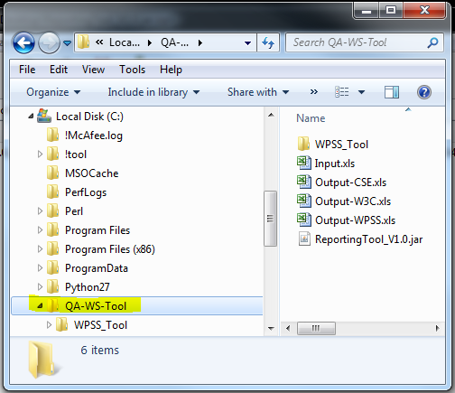
Figure 1 - Directories and Files

What Do the 5 Files Represent?
The 5 files are: A) Input.xls, B) Output-CSE.xls, Output-W3C-xls, Output-WPSS.xls and C) ReporitngTool_v1.0.jar

A) Input.xls
The Input.xls file contains 3 tab-sheets that list the checkpoints for the 3 Web standards:
- Web Accessibility
- Web Usability (N/A)
- Web Interoperability
The Input.xls file is your starting set-up file where you must add all French and English URLs to be tested. Add the URL(s) in the same order in all 3 separate tab-sheets (Figure 2).
IMPORTANT NOTE: EACH URL MUST HAVE HTTP or HTTPS INDICATED
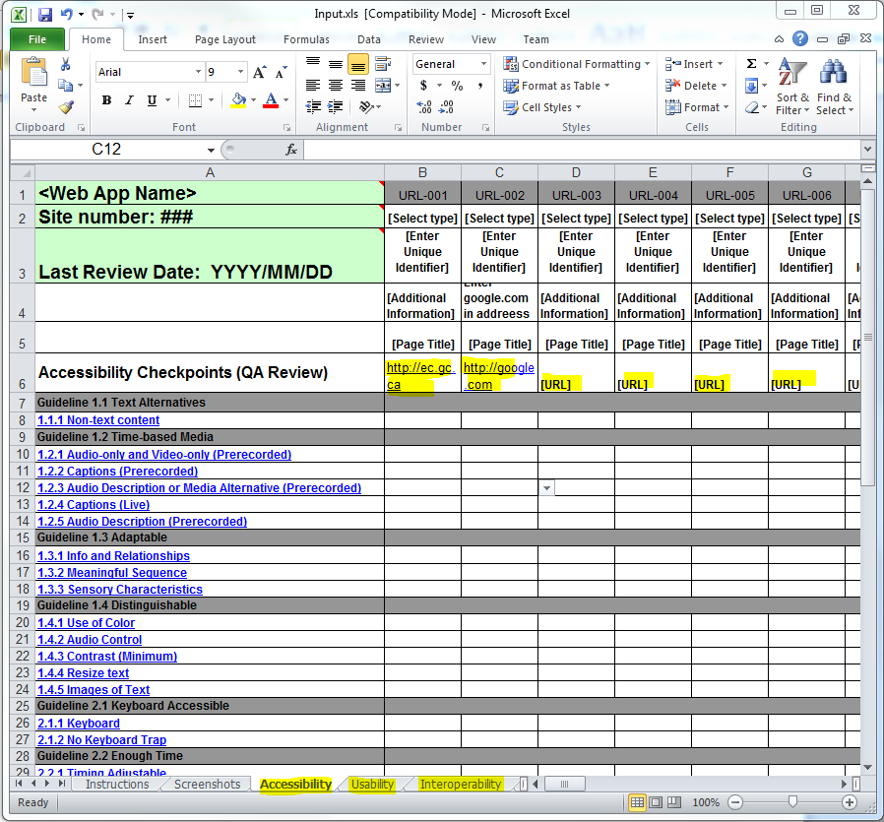
Figure 2 - A look at the tab-sheets and URL location.

B) Output-WPSS.xls; Output-CSE.xls; and Output-W3C.xls
These 3 files represent the review results files of the automation testing. Each test - weather WPSS, CSE or W3C - must be done separately where results are found in specific Output files.
For each result you will get a conformation/Congratulation message (Figure 3).
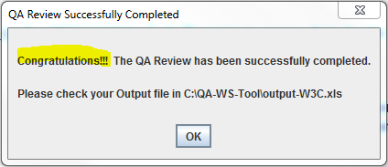
Figure 3 - Confirmation - Congratulations Message
Always SAVE AS each Output file and RENAME file before viewing report.

C) ReportingToolV1.0.jar (START)
This is your start file to double click once YOU have already added the URLS for testing in your Input.xls file.
To Start: Launch Reporting Tool JAR file: ReporitngTool V1.0.jar (Figure 4).
IMPORTANT NOTE: ALL EXECEL SHEETS MUST BE CLOSED BEFORE LAUCHING THIS FILE.
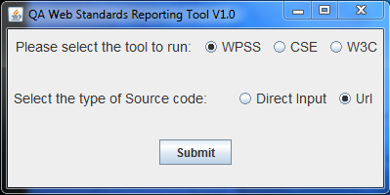
Figure 4 - QA Web Standards Reporting Tool V1.0

GENERATE A REPORT - QA TESTING
Each report starts when you select a tool to run and select a type of source to test and the Submit.
Please be patient. Each link takes about 30 seconds before confirmation/congratulation message appears. The more links the more time it takes per report.
This pop-up appears when you click on the ReporitngTool V1.0.jar start file (Figure 5).
Figure 5 - QA Web Standards Tool V1.0
When the QA test review is completed, a Congratulation test message appears (Figure 6).
Figure 6 - - QA Review Successfully Completed

Quick Steps
Step 1: Add URL(s) (including the http or https) to the Input.xls master file found: C:\QA-WS-Tool\
Step 2: Click on the ReportingTool V1.0.jar to start QA automation tool
Step 3: Select Tool to Run and select type of Source code
Step 4: Click Submit
Step 5: Wait for Congratulation Message and click OK
Step 6: SAVE AS Output file and RENAME before viewing results. E.g. If you generated a WPSS report, locate the Output-WPSS.xls files and SAVE AS and RENAME before viewing report

